CHAPTER 3: REQUIREMENTS AND ANALYSIS
This chapter defines the problem addressed by the AI-Rescue: Intelligent Disaster Response & Resource Coordination Platform, identifies the functional and non-functional requirements, describes the project planning and scheduling, specifies the required hardware and software environment, and presents the preliminary description and conceptual models of the proposed system.

3.1 Problem Definition
Natural disasters such as floods, earthquakes, cyclones, landslides, fires, and severe storms can affect large populations within a short period of time. During such situations, emergency authorities need accurate information about incidents, affected people, available resources, rescue teams, hospitals, and shelters.
A major challenge in disaster response is the coordination of information and resources. Incident reports may arrive from different sources, while emergency personnel may need to manually verify reports, determine their priority, identify available resources, and coordinate the response. This can result in delays, inefficient resource utilization, duplicate efforts, and difficulty in maintaining a centralized view of ongoing incidents.
The proposed AI-Rescue platform addresses this problem by providing a centralized web-based system for disaster incident reporting, incident verification, resource management, emergency coordination, notifications, and reporting.
The system also incorporates an AI-assisted decision-support component. After an incident has been verified by an authorized officer, the AI component analyzes relevant incident information and provides recommendations regarding severity, priority, and required resources. These recommendations are reviewed by the authorized officer before operational action is taken.
Therefore, the primary problem addressed by the project is:
To develop a centralized and intelligent disaster-response platform that improves incident management, resource coordination, communication, and decision support while reducing delays in emergency response operations.

3.2 Requirements Specification
The requirements of the AI-Rescue platform are divided into functional requirements and non-functional requirements.
3.2.1 Functional Requirements
FR-01: User Registration
The system shall allow new users to register by providing the required personal and account information.
FR-02: User Authentication
The system shall authenticate users using valid login credentials.
FR-03: Role-Based Access
The system shall provide different access permissions according to the user's assigned role.
Possible roles include:
- Citizen
- Volunteer / Support User
- Officer
- Administrator
FR-04: Disaster Incident Reporting
The system shall allow authorized users, particularly citizens, to submit disaster incident reports.
An incident report may contain:
- Disaster type.
- Incident title.
- Description.
- Location.
- Latitude and longitude.
- Number of people affected.
- Severity-related information.
- Supporting evidence.
FR-05: Incident Validation
The system shall validate the information entered during incident submission before storing the incident.
FR-06: Incident Verification
The system shall allow an authorized officer to review submitted incidents and determine whether an incident is genuine/valid.
Invalid incidents can be rejected and the relevant user can be notified.
FR-07: Incident Management
The system shall maintain the status and lifecycle of incidents from reporting through resolution.
FR-08: AI-Assisted Analysis
After an incident has been verified, the system shall send relevant incident information to the AI component for analysis.
The AI component shall provide decision-support information such as:
- Severity assessment.
- Priority recommendation.
- Required resource recommendation.
- Confidence score.
The AI output shall be treated as a recommendation, not as an automatic operational decision.
FR-09: AI Recommendation Review
The authorized officer shall be able to review the AI-generated recommendations before taking operational action.
FR-10: Resource Management
The system shall maintain information about available emergency resources.
Resources may include:
- Rescue resources.
- Vehicles.
- Equipment.
- Other response assets.
FR-11: Resource Availability
The system shall allow authorized users to check the availability and status of response resources.
FR-12: Resource Assignment
The system shall allow authorized officers or administrators to assign available resources to verified incidents.
The assignment may include vehicles, equipment, and other resources.
FR-13: Emergency Service Information
The system shall maintain information related to emergency facilities such as hospitals and shelters.
Hospital information may include emergency capacity and available beds, while shelter information may include capacity and current occupancy.
FR-14: Notifications
The system shall generate notifications for relevant users regarding important incident and operational events.
Examples include:
- New incident notification.
- Incident verification result.
- Resource assignment notification.
- Response-status update.
- Other emergency notifications.
FR-15: Incident Status Management
The system shall allow authorized users to update the status of an incident during the response process.
Possible states may include:
Reported
↓
Under Review
↓
Verified
↓
Response Initiated
↓
In Progress
↓
Resolved
↓
Closed
FR-16: Dashboard
The system shall provide dashboards for authorized users to monitor relevant disaster-response information.
The dashboard may display:
- Active incidents.
- Incident priorities.
- Resource availability.
- Response status.
- Notifications.
- Summary information.
FR-17: Report Generation
The system shall allow authorized users to generate reports based on stored system information.
FR-18: Audit Logging
The system shall record important system activities for traceability and accountability.
FR-19: System Settings
The administrator shall be able to manage relevant system configuration settings.

3.2.2 Non-Functional Requirements
NFR-01: Security
The system should protect user accounts and sensitive operational information through authentication, authorization, secure password storage, and role-based access control.
NFR-02: Performance
The system should respond to normal user requests within a reasonable time and should efficiently handle incident and resource data.
NFR-03: Reliability
The system should maintain data consistency and minimize failures during normal operation.
NFR-04: Usability
The interface should be simple and understandable so that users can perform required operations without unnecessary complexity.
NFR-05: Scalability
The architecture should allow additional users, incidents, resources, and future services to be incorporated without major changes to the overall design.
NFR-06: Maintainability
The application should use a modular architecture so that individual components can be modified or enhanced independently.
NFR-07: Data Integrity
The database should maintain accurate and consistent information using primary keys, foreign keys, constraints, and appropriate validation.
NFR-08: Availability
The system should be designed to remain accessible during normal operational periods and should support recovery from common application or database failures.
NFR-09: Extensibility
The architecture should allow future integration with technologies such as IoT devices, weather services, mapping services, mobile applications, and external emergency systems.

3.3 Planning and Scheduling
The development of AI-Rescue is divided into several stages to ensure that the system is developed systematically.
Table 3.1: Work Breakdown Structure & Execution Timeline (June 2026 – February 2027)
ID | Work Package / Activity | Start Date | End Date | Days | Category | Key Deliverable
01 | Project Inception, Scope & Feasibility | 23 Jun 2026 | 28 Jun 2026 | 6d | Planning & Initiation | Project Charter
02 | Requirement Gathering & Tech Survey | 29 Jun 2026 | 09 Jul 2026 | 11d | Planning & Analysis | Survey Report
03 | Software Requirements Specification (SRS) | 10 Jul 2026 | 19 Jul 2026 | 10d | Requirements Analysis | SRS Document
04 | System Architecture & High-Level Design | 20 Jul 2026 | 29 Jul 2026 | 10d | System Architecture | Architecture Blueprint
05 | Database Design & ER Modeling (Master ERD) | 30 Jul 2026 | 08 Aug 2026 | 10d | Database Engineering | ER Diagrams & DDL
06 | Data Flow Diagrams (DFD Level 0 & Level 1) | 09 Aug 2026 | 16 Aug 2026 | 8d | Process Modeling | DFD Specifications
07 | UML Modeling (Use Case & Sequence Diagrams) | 17 Aug 2026 | 25 Aug 2026 | 9d | Object-Oriented Design | UML Diagrams
08 | System Flowchart & Module Logic Diagrams | 26 Aug 2026 | 03 Sep 2026 | 9d | Procedural Design | Logic Flowcharts
09 | UI/UX Wireframes & AI Architecture Spec | 04 Sep 2026 | 12 Sep 2026 | 9d | Interface & AI Design | UI Prototypes
10 | Phase 1 Documentation (Chapters 1 to 4) | 23 Jun 2026 | 18 Sep 2026 | 88d | Academic Documentation | Draft Chapters 1–4
11 | Review, Diagram Verification & Corrections | 19 Sep 2026 | 24 Sep 2026 | 6d | Quality Assurance | Review Sign-off
12 | Phase 1 Final Interim Submission & Freeze | 25 Sep 2026 | 25 Sep 2026 | 1d | Milestone 1 | Interim Report Submission
13 | Dev Setup, Scaffolding & DB Migration | 26 Sep 2026 | 08 Oct 2026 | 13d | Core Full-Stack Dev | Dev Environment & Baseline
14 | Backend Services & REST APIs (Spring Boot) | 09 Oct 2026 | 02 Nov 2026 | 25d | Backend Engineering | REST API Endpoints
15 | Frontend Web & Mobile Portal (React.js UI) | 24 Oct 2026 | 20 Nov 2026 | 28d | Frontend Engineering | Responsive UI Views
16 | AI Decision-Support & Severity Index Engine | 15 Nov 2026 | 10 Dec 2026 | 26d | AI & NLP Services | Triage & Ranking Model
17 | GIS Interactive Mapping & Resource Dispatch | 01 Dec 2026 | 24 Dec 2026 | 24d | Geo-Spatial & Dispatch | GIS Map & Routing
18 | Shelter, Hospital & Notification Services | 18 Dec 2026 | 08 Jan 2027 | 22d | Integration Services | Alert & Capacity Engines
19 | System Integration & End-to-End Testing | 05 Jan 2027 | 25 Jan 2027 | 21d | Quality Assurance | Test Case Execution Report
20 | User Acceptance Testing & Cloud Deployment | 22 Jan 2027 | 08 Feb 2027 | 18d | Deployment & Hosting | Production Cloud URL
21 | Phase 2 Documentation (Chapters 5, 6 & 7) | 15 Jan 2027 | 18 Feb 2027 | 35d | Academic Documentation | Final Chapters 5–7
22 | Final Project Submission & Degree Defense | 26 Feb 2027 | 28 Feb 2027 | 3d | Milestone 2 | Project Defense / Viva
The project schedule was prepared using a Gantt chart to organize the major activities of the AI-Rescue project from initial planning through final documentation and submission.
The project schedule was prepared using an academic Gantt chart to organize and track the major work packages of the AI-Rescue platform across both Phase 1 (Planning, Requirement Analysis, Architecture & System Design) and Phase 2 (Full-Stack Implementation, AI Priority Engine, GIS Services, Quality Assurance, Cloud Deployment, Final Documentation and Viva Defense).
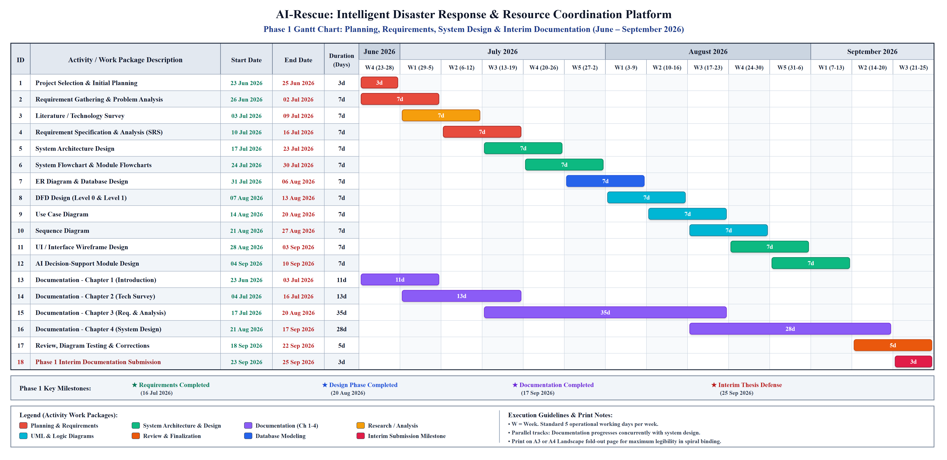
Figure 3.1: Gantt Chart – Phase 1: Planning, Requirements, System Design & Interim Documentation (June 2026 – September 2026)
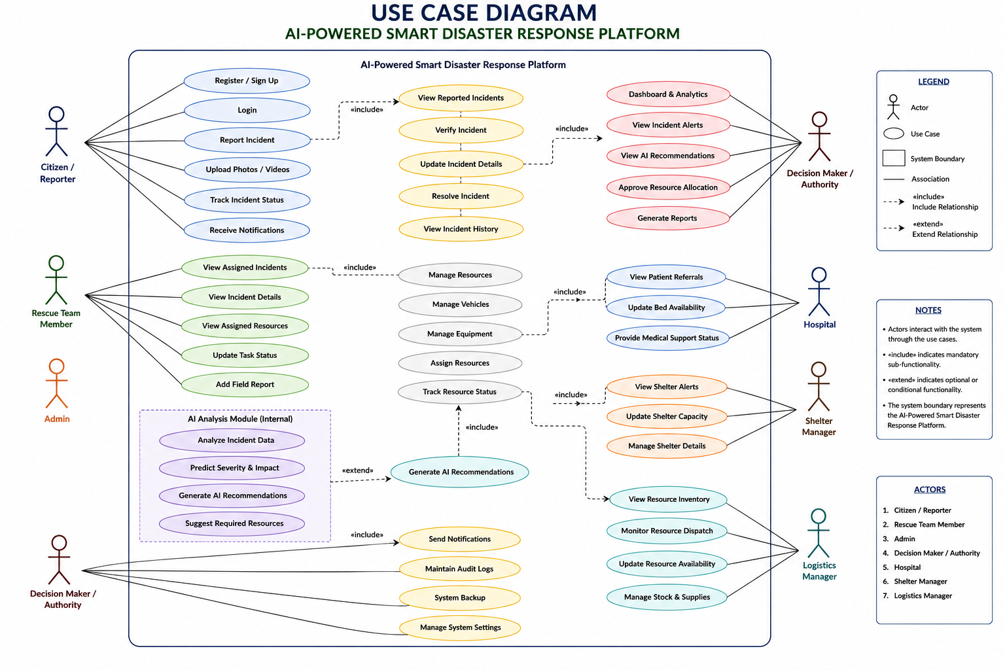
Figure 3.2: Gantt Chart – Phase 2: Core Full-Stack Development, AI Engine, Testing, Cloud & Final Defense (September 2026 – February 2027)
The project schedule is structured into two standalone execution phases. Phase 1 (Figure 3.1) encompasses initial problem definition, requirements engineering, SRS specification, architectural modeling (DFDs, ERDs, UML diagrams), and Chapters 1–4 interim documentation, concluding on 25 September 2026. Phase 2 (Figure 3.2) initiates immediately on 26 September 2026 without interruption, covering core Spring Boot backend services, PostgreSQL database schema migrations, React web portal development, AI decision-support algorithms, GIS routing, automated testing, cloud deployment, and final thesis defense by 28 February 2027.
The Gantt chart shows the planned timeline and duration of each major project activity. Activities are arranged according to their dependencies, with overlapping tasks where appropriate.
3.4 Software and Hardware Requirements
3.4.1 Software Requirements
The proposed development environment requires the following software:
Software | Purpose
Operating System | Windows / Linux
Java JDK | Java application development
Spring Boot | Backend development
Python | AI/ML development
Scikit-learn | Machine learning
PostgreSQL | Database management
Visual Paradigm | System modelling and diagrams
Web Browser | Application testing
Git | Version control
GitHub | Repository management
IDE | Java/Python application development
The exact IDE can be selected according to development convenience.

3.4.2 Hardware Requirements
A standard modern computer system is sufficient for developing the academic version of the platform.
Minimum Recommended Configuration
Component | Requirement
Processor | Intel Core i5 / equivalent
RAM | 8 GB minimum
Storage | 256 GB or higher
Network | Internet connection
Display | Standard monitor
Input | Keyboard and mouse
Recommended Configuration
Component | Requirement
Processor | Intel Core i5/i7 or equivalent
RAM | 16 GB
Storage | 512 GB SSD
Network | Stable broadband connection
A dedicated high-end GPU is not required for the initial academic version if the AI component uses conventional machine-learning models rather than large deep-learning models.

3.5 Preliminary Product Description
The AI-Rescue platform is proposed as a centralized web-based disaster management and response coordination system.
The platform provides a common environment where different stakeholders can interact with disaster-related information according to their roles.
The major capabilities of the system include:
1. User Management
Users can register and authenticate themselves. Role-based permissions determine the operations available to each user.
2. Incident Management
Citizens can report disaster incidents by providing structured information and optional supporting evidence. Officers can review, verify, reject, and manage incidents.
3. AI Decision Support
Once an incident has been verified, the AI module analyzes relevant information and generates recommendations related to severity, priority, and required resources.
4. Resource Coordination
Authorized officers can view available resources and assign appropriate resources to verified incidents.
5. Hospital and Shelter Information
The platform maintains emergency-service information such as hospital capacity, available beds, shelter capacity, and current occupancy.
6. Notification Management
The system provides notifications to relevant users based on incident and operational events.
7. Dashboard and Reporting
Authorized users can monitor disaster-response activities through dashboards and generate reports from stored information.
8. Audit and Administration
Important system activities are recorded through audit logs, while administrators can manage system configuration.

3.6 Conceptual Models
Conceptual models provide a high-level representation of how the proposed system operates and how its components interact.
The major conceptual models prepared for AI-Rescue are:
- Data Flow Diagram (DFD)
- Use Case Diagram
These models describe different aspects of the same system.

3.6.1 Data Flow Concept
At a conceptual level, information flows through the system as follows:
- DFD Level 0
The Level 0 Data Flow Diagram provides a high-level view of the AI-Rescue system and shows how data is exchanged between external entities and the system.
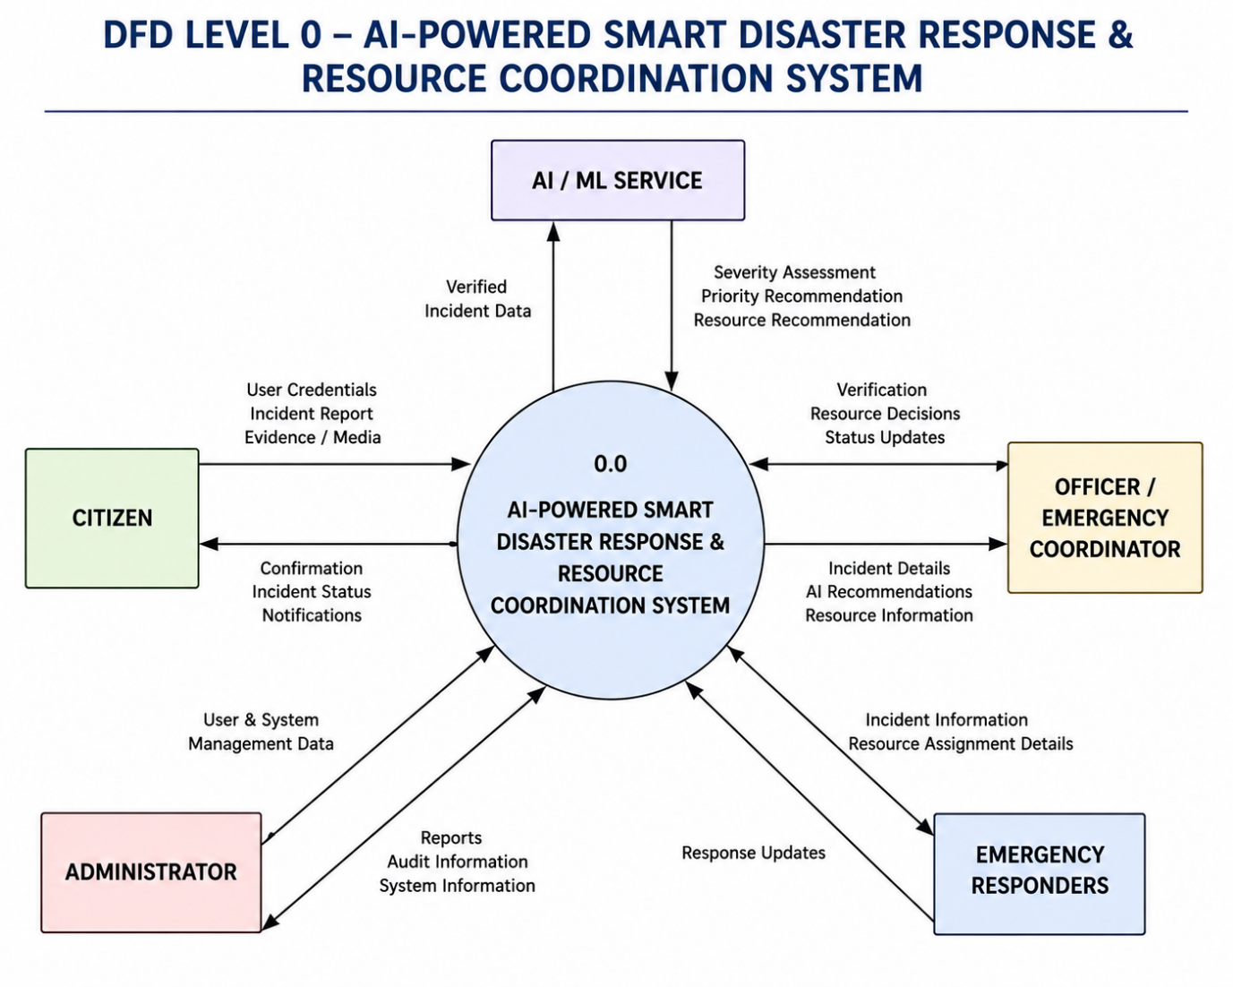
Figure 3.3: Data Flow Diagram – Level 0
The diagram represents the major input and output data flows between users and the disaster response platform.

- DFD Level 1
The Level 1 DFD decomposes the major processes of the AI-Rescue system into more detailed processes.
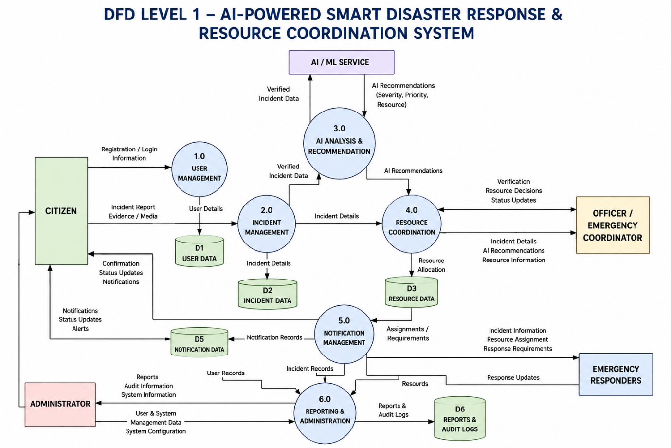
Figure 3.4: Data Flow Diagram – Level 1
This expands the major processes of the Level 0 DFD.
It illustrates the flow of incident information, verification data, AI recommendations, resource information, notifications, and response updates within the system.

3.6.2 Use Case Diagram
The Use Case Diagram represents the interactions between different users and the AI-Rescue system. It identifies the major actors and the functions available to each actor.
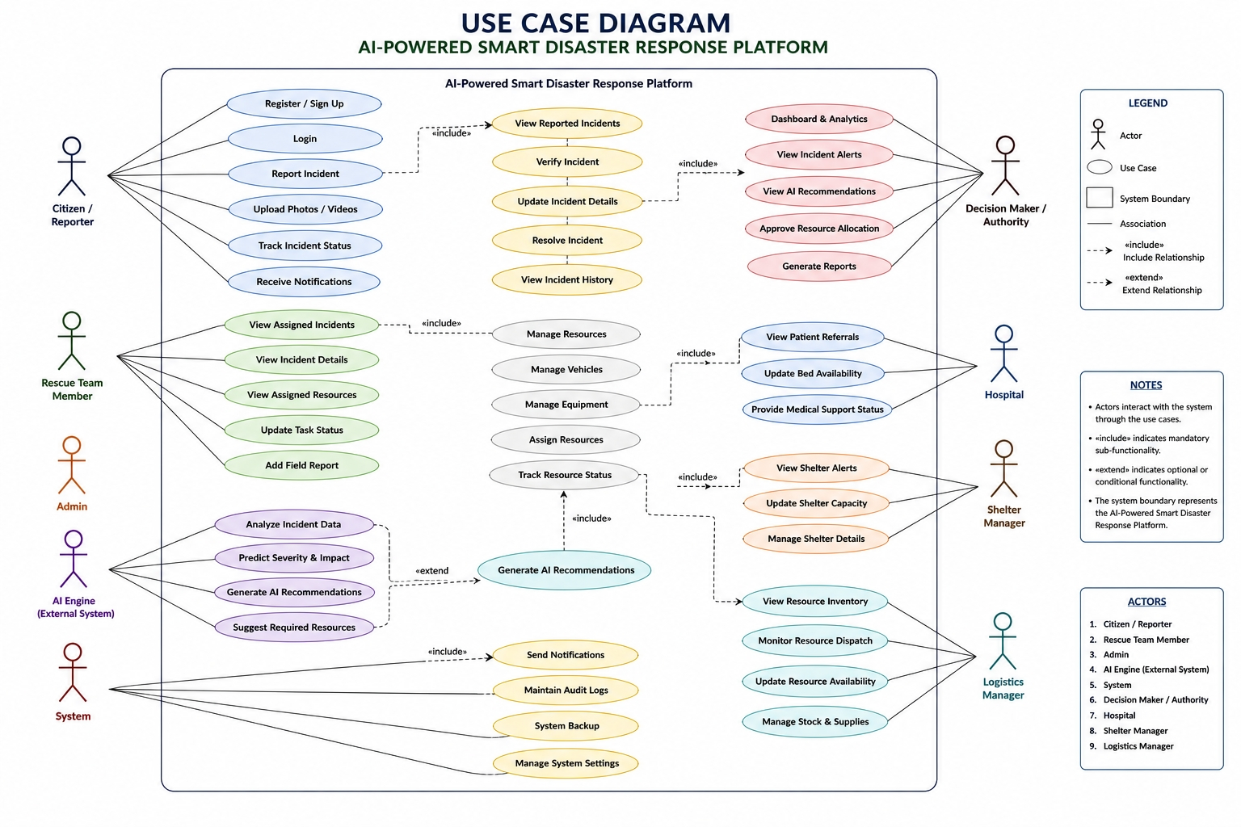
Figure 3.5: Use Case Diagram – AI-Powered Smart Disaster Response Platform
The diagram shows the major system functions performed by citizens, volunteers, officers, hospital and shelter personnel, and administrators according to their assigned roles.

